Name: Muhammd Sherjeel Akhtar
Section: BCS-3D
Subject: Computer Organization And Assembly Language
Task: Report Of Lab 1

About Report:
This is the report of our very first lab of computer oraganiztion and assembly language. Starting with an intro of the COAL, so basically in COAL, we are going to look deep into the computer components and hardware. In addition to it we are going to enlighten the importance of Assembly language and how we can make this language useful in terms of interacting with machines.
Tasks Enlisted In Report:
Following tasks are completed and being mention in this report.
1: What is COAL?
2: Assemblers
3: MASM
4: Website of MASM
5: Downloading f MASM
6: Installation of MASM
7: Writing code in MASM
8: Assembling and linking of code
9: Building of program
10: Execution/Running of code
Assemblers:
As COAL is an assembly language, so there are emulators which are going to assemble the codes of assembly language. These emulators are called as Assemblers.
MASM:
MASM is an assembler that is being used to assemble, edit and to run the code of assembly language.
Downloading Of MASM:
Now we are going to download the MASM from their official website. I’m pasting the link here. Click on the link to go to the official site of MASM.
Link: https://www.masm32.com/
Here is a demonstration of Downloading of MASM by images.
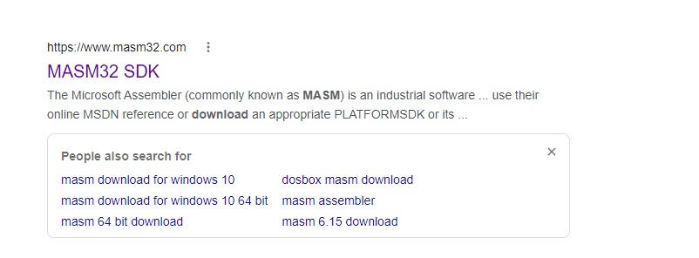
Now click on this link and you’ll be at the main site of MASM.
Then click Download to proceed the process.


Then click on the Western Europe Head and it’ll take to you to the final destination of downloading.
Then click on the MASM-32 Package to start the download of MASM..
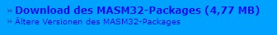

Here is a live picture of its downloading.


Installation Of MASM:
Now, the MASM has been downloaded. Simply click on the zip folder. It’ll look like this.
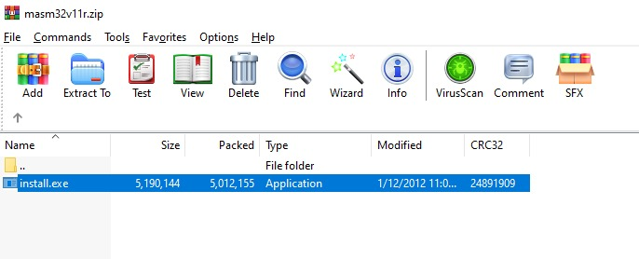
Simply extract the files from the given ZIP folder.
Have a look on the unzip file.
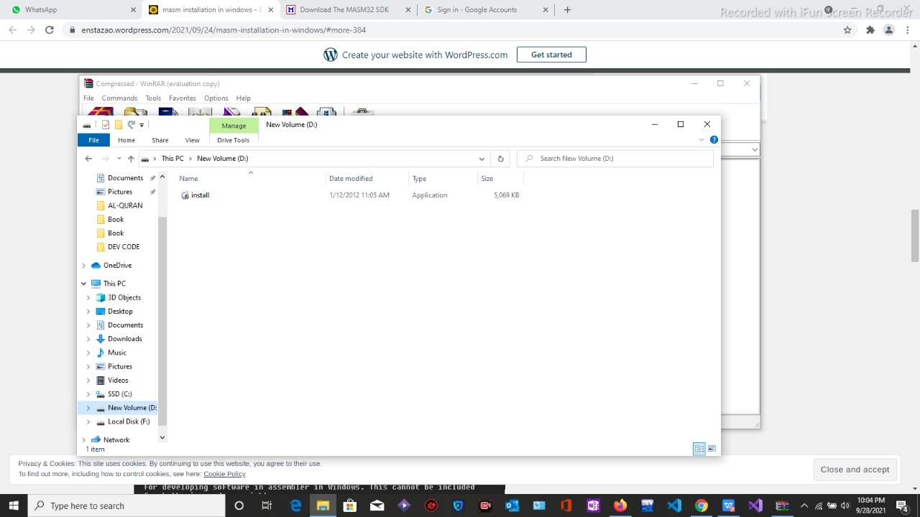
Now click on the main file which is shown in the picture.
An installation like this will open.
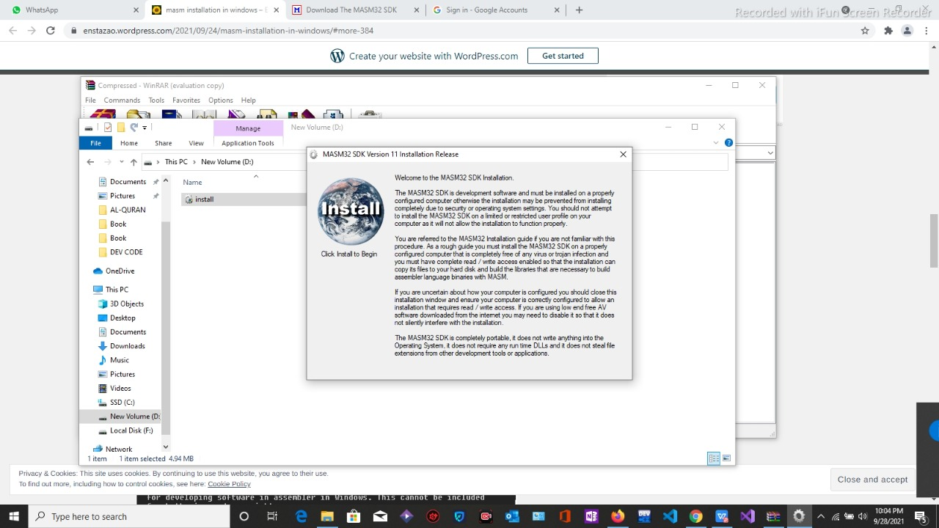
Simply press the next for few times. Let the default settings be there. Don’t change the default values and destinations during the installation.
Soon the software will starting installing its data. Look at the preview of it.
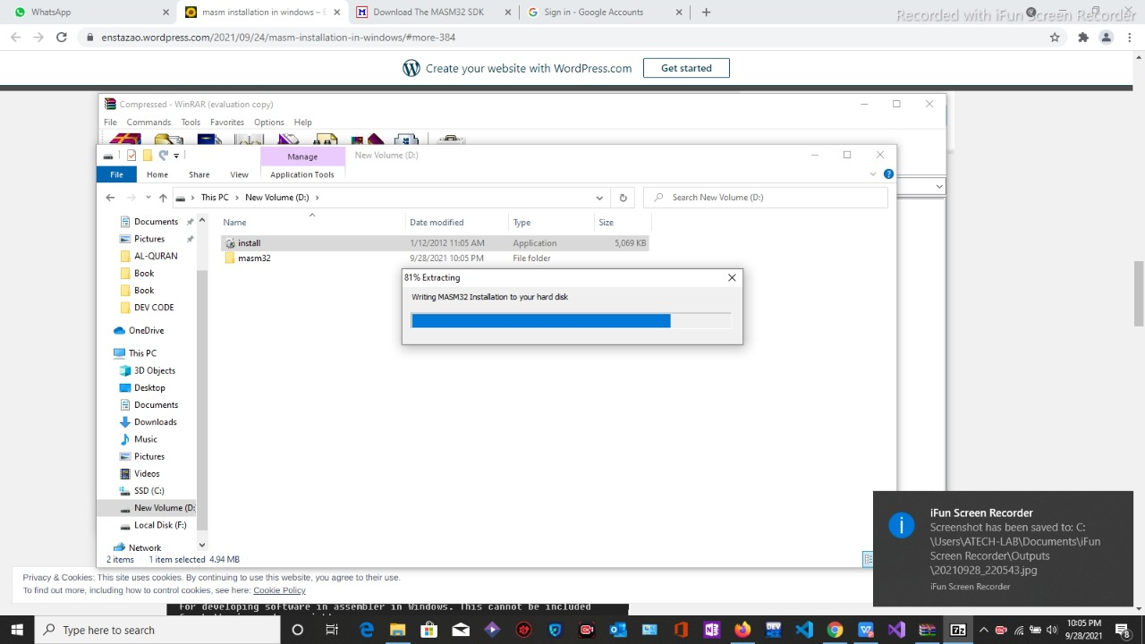
This message will appear after the installation of the software.
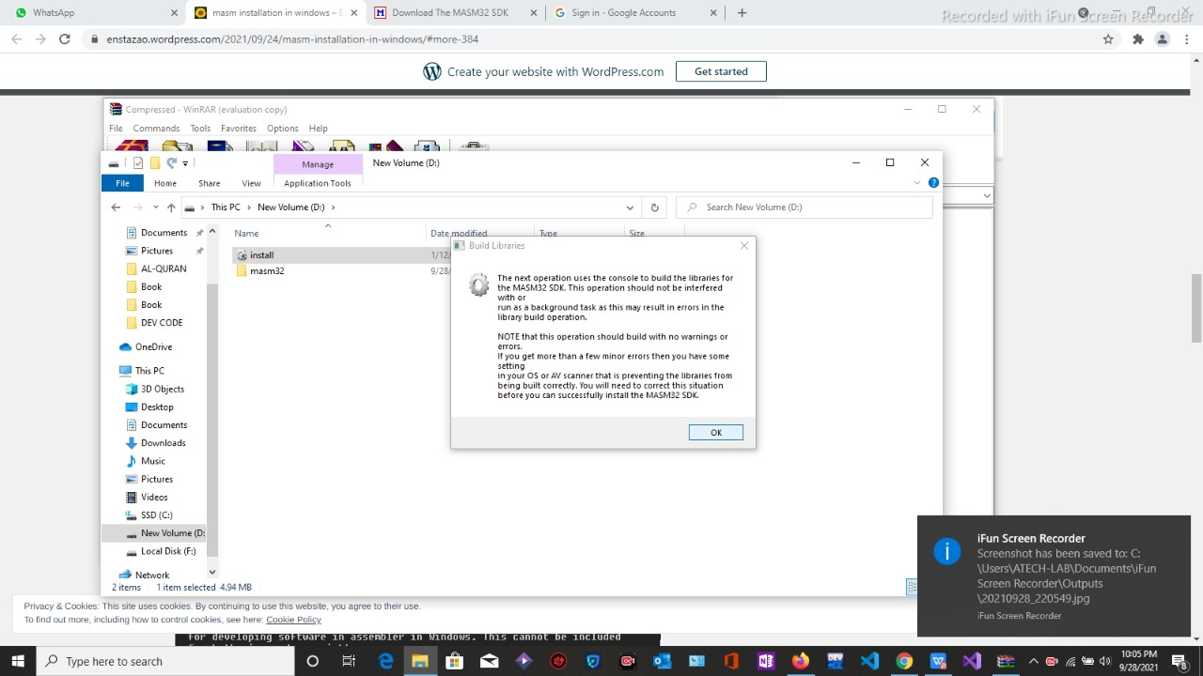
Now the installation is completed. Simply click the OK to close the finish box.
Writing Code In MASM:
Now we are going to write the code in the MASM. A dummy code is present on the slate. Simply copy the code, paste in in the interface of MASM. Go to Save As in the file option. Save the file with an extension of .asm.
The demonstration of it by a picture is as below.
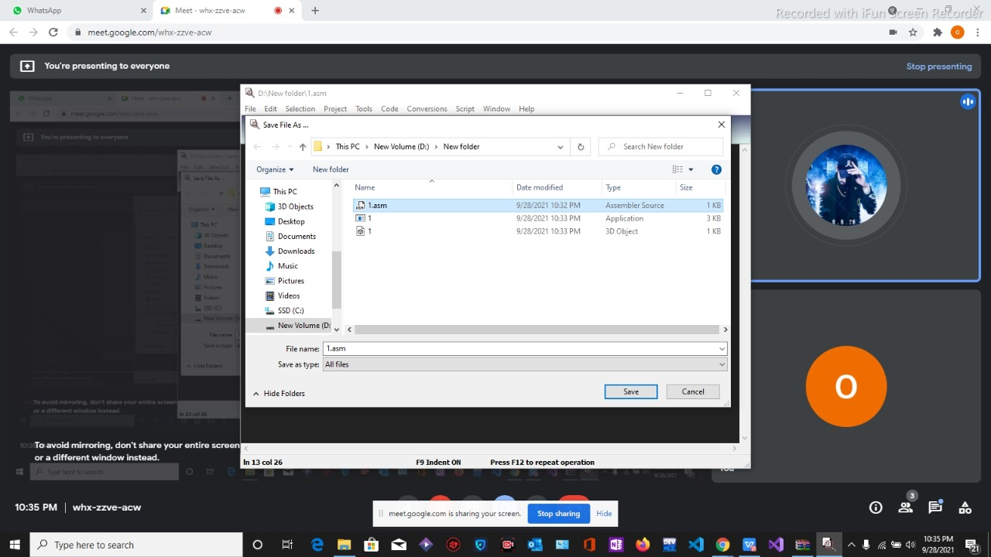
Assembling And Linking Of Code:
Now we will link and assemble the code. Simply go to the project header and select Assemble and Link from it as shown below.
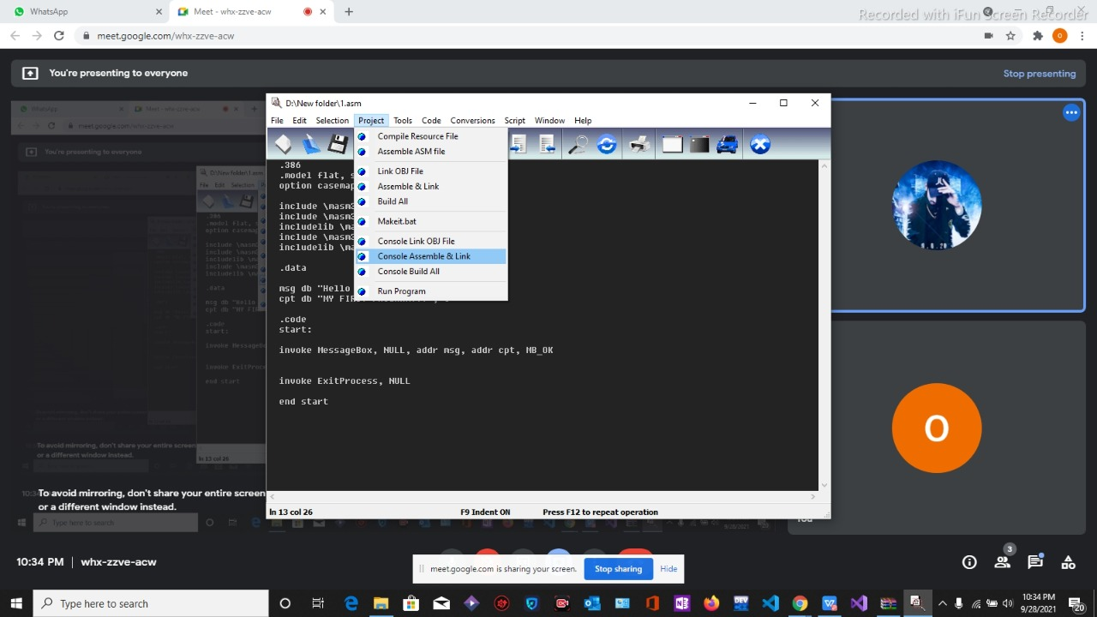
The assembling and linking of code will cause of an opening of a black box with some sort of sentences with numerical values written on it.
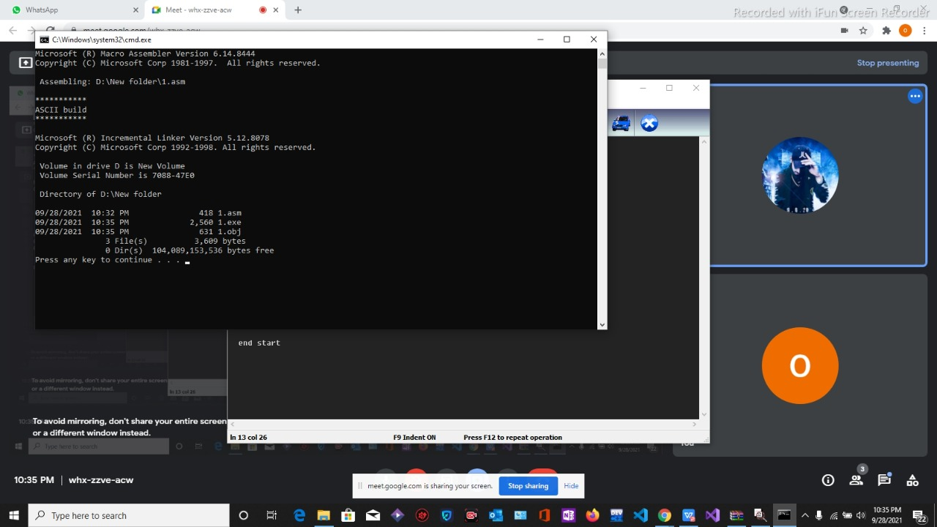
Building Of Code:
Now again go to the Project head. Select the option of build all from it and it will start building the program. This is given by.

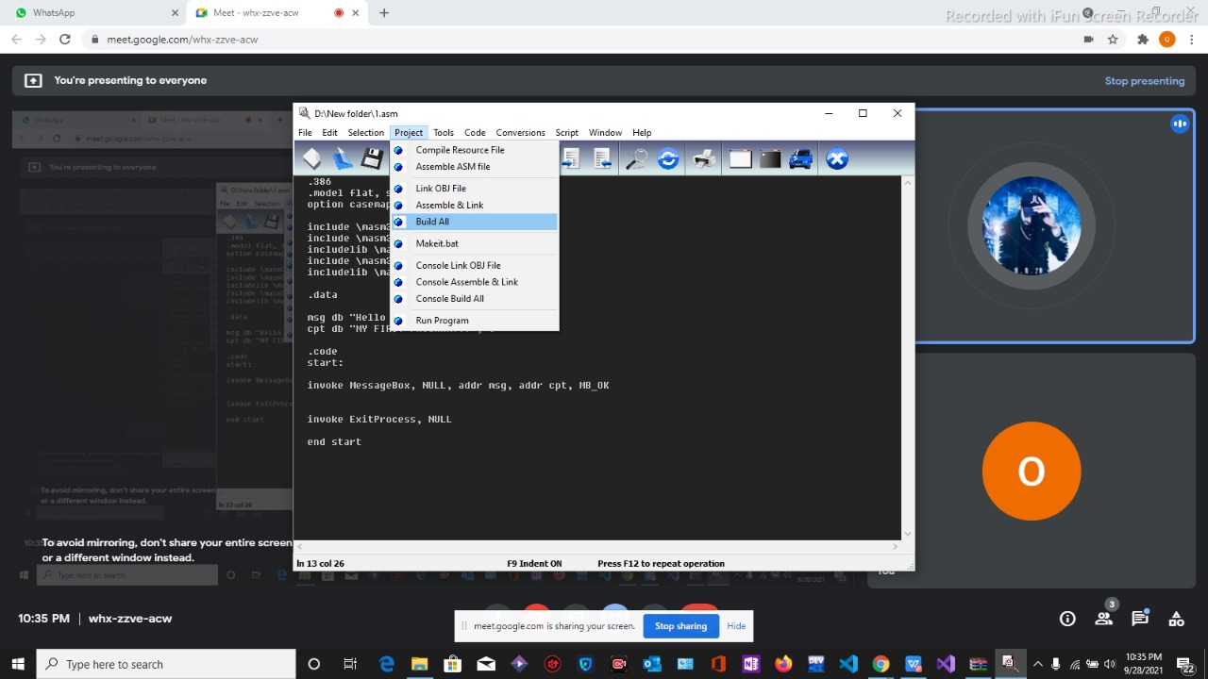
Now our program is fully build.
Running Of Code:
Now we are going to run the code. Simply go to the project head and select the RUN PROGRAM option. This will run the program and if the program run successfully, Hello World appeared on the screen as shown below.
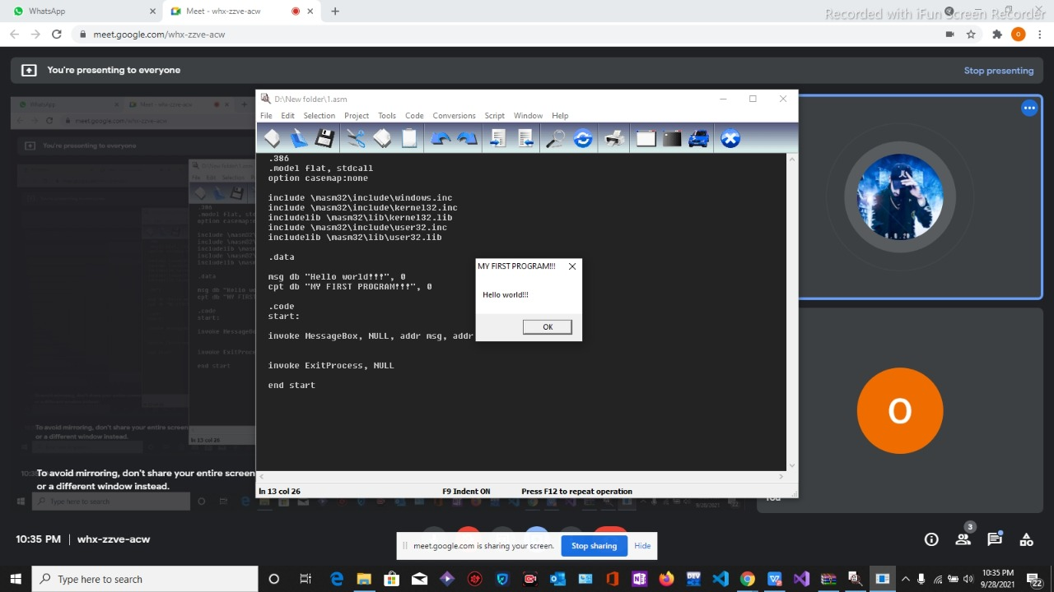
This is the final running of our program. This was all the work that we have completed in our last lab. If you face any error, kindly do check the code or the extension of the saved file. Usually errors not commonly occur in Assembly Language because Assembly Language is a very strong language.

